A

Project Report on

Car Rental System

Submitted to

Savitribai Phule Pune University

In the partial fulfillment of the requirement of the award of the degree of

Bachelor of Business Administration- Computer Application,

TYBBA -CA, Sem VI

Academic Year 2020-21

By

Atharva N. Rao & Tejas V. Valame

Under the guidance of

Prof. Minal Datta

Through



Alandi (D) - Pune 412105



CERTIFICATE

Department of Computer Application

This is to certify that Mr. Atharva N. Rao & Mr. Tejas V. Valame, of TYBBA-CA, Sem V, Exam Seat No. TB212 & TA114 , has successfully completed project work entitled Digital Examination System in the partial fulfillment of the requirement of the degree of Bachelor Of Business Administrator-Computer Application for the Academic Year 2020-21.

Prof. Minal Datta Prof. Akshada Kulkarni

Project Guide Head of the Department

Internal Examiner External Examiner

**Acknowledgement**

The words are not enough to express my thanks to **Dr. B. B. Waphare**, **Principal, MIT Arts Commerce and Science College Alandi (D)** for providing me with the opportunity to avail the excellent facilities and infrastructure of the institute.

It is my proud privilege to express my profound gratitude to **Prof. Akshada Kulkarni, HOD, Computer Application Department**, for her astute guidance, constant encouragement and sincere support throughout my academic course.

I thank to my honest gratitude to **Prof. Minal Datta** for her inspiration, constructive suggestions and affectionate guidance in our project work completion.

Last but not the least, I express my sincere thanks to all my dear friends and family members for their constant motivation, moral support and invariable direction throughout my life.

**DECLARATION**

I, **Atharva N. Rao, Tejas V Valame,** hereby declare that this project work entitled Car Rental System submitted at MIT, Arts Commerce and Science College, Alandi(D), (Affiliated to Savitribai Phule Pune University) is a record of original work done by us under the supervision and guidance of **Prof. Minal Datta**, Department of Computer Application.

Signature :

1. Name of Student : Atharva N. Rao

Exam Seat No. :

2) Name of Student : Tejas V. Valame

Exam Seat No.:

Place : Alandi (D), Pune

Date :

**Index**

|  |  |  |
| --- | --- | --- |
| **Sr. No** | **Title** | **Page No** |
| **1** | Introduction  Introduction to system  Scope of the system  Proposed & Existing System | **6**  **7**  **8** |
| **2** | Analysis  Fact Finding Techniques  Feasibility Study  Hardware & Software Requirements | **9**  **11**  **12** |
| **3** | System Design  E-R Diagram  Data Flow Diagram  Data Dictionary | **13**  **14**  **17** |
| **4** | Form Design (with input values) | **20** |
| **5** | Reports | **25** |
| **6** | Advantages & Limitations | **27** |
| **7** | Future Enhancement | **28** |
| **8** | Bibliography | **29** |

**Introduction to System**

The Car Rental Service system is being developed for customers so that they can book the vehicles from this system. This application takes information from customers through filling their details. A customer being registered in the system has the facility to book a vehicle which he/she requires. The proposed system is completely integrated desktop based systems. It’s a manual procedure in an effective way. This automated system facilitates customers and provide to fill up the details according to their requirements. It includes types of vehicles they are trying to hire according to their location. The purpose of this system is to develop a desktop based system application for the person who wants to book their vehicles along with their requirements.

**Scope of System**

* This new system allows security to the data, by means of authorized users. Only the admin having a valid user name and password can access the material.
* Rest all users can view only the basic information.
* The proposed system provides information about the system details.
* Front end provides faster interaction, while back end provides interaction with records.
* The new system will allow the admin to quickly insert, delete, update and retrieve data from the system.

**Proposed & Existing System**

**Existing System:**

The problems faced in managing the manual system are as follow:

* Time Consuming: Being a manual system it is time consuming and resulted in increased workload.
* Increased Errors and Mistakes: Due to tedious and fatigue nature of the task, the system resulted in increased errors and mistakes. It is Difficult in locating the information.
* Difficulty in Maintaining Reports: Keeping track of various records like booking forms, cancellation form etc. leads to numerous errors.
* Difficulty in modifying any information: Saving changes would require user to make new record and maintain it.

**Proposed System:**

The proposed system facilitates the customer to fill up their details and to give a brief description of a vehicle they want to book. This new system is very much helpful for customer who wants to hire a vehicle according to their needs. It is also less time consuming as user has to enter the data once and retrieve it every time the customer hires a car. Maintaining reports is very easy as the system generates the reports automatically when the admin wishes to.

**Fact Finding Techniques**

Fact-finding is process of collection of data and information based on techniques, which contain sampling of existing components, research, observation, questionnaires, interviews, requirements planning.

Fact find search method is:

1. Interview
2. Questionnaires
3. Record review
4. Observation
5. Interview:

Interview is the most commonly used technique to collect information from the face-to-face interviews. The purpose of interview is to find and verify facts, identify requirements and gather ideas and opinions. The role of interview includes interviewer and interviewee who are system owner or user.

1. Questionnaires:

It is use as the supplements to the interview, it content two types are as follows:

* Open ended: Like what the major and minor problems in the existing system?
* Closed ended: In which it include the fixed response like, The closed questions can be of various types and the most common ones are listed below.

a. Fill-in-the-blanks.

b. Yes or No type.

c. Ranking scale questions ask the respondents to rank a list of items in the order of importance or preference.

d. Multiple-choice questions which offer respondents few fixed alternatives to choose from.

e. Rating scale questions are an extension of the multiple-choice questions. Here the respondent is asked to rate certain alternatives on some given scale.

1. Record review:

Sometimes the best way to analyze the existing system is to collect facts from existing documentation rather than from human sources. There are various kinds of documents to collect facts from existing documents. These include e-mails, customer complaints and suggestion box notes. Simply re-organizing these documents helps a lot.

1. Observation :

Another fact finding technique is observation. In this technique, system analyst participates in the organization, studies the flow of documents, applies the existing system, and interacts with the users. Observation can be a useful technique when the system analyst have user point of view.

**Feasibility Study**

Feasibility study is a test of system proposal according to its workability, impact of the organization, ability to meet needs and effective use of the resources. This project on car rental service system is highly feasible. It accomplishes all the feasibility requirements to develop good desktop based system.

1)Economic Feasibility:

* It does not incur much development cost.
* The system does not have much software and hardware requirement.
* The system does not require any employees for maintenance.

2)Technological Feasibility

* The working of the project is quietly simple.
* The project is user friendly and so this new technology will save a lot of time of both user and management.
* The flow of the project is not complicated and so even if a new user uses the system, he/she can understand the system easily.

3)Operational Feasibility

* As the system is user friendly and easy to operate any person with basic knowledge of windows form can able to handle this system.
* It is also easy to operate due to the friendly interface developed by using Visual Studio 2008.
* There is no need on any training to users for using this system.

**Hardware & Software Requirements**

**Hardware Requirements:**

**Processor:** Intel Pentium(R) Dual CPU

**RAM:** 2.00 GB

**Hard disk:** 30 GB or more

**Software Requirement:**

**Operating System:** Windows 7, Windows 8,Windows XPProfessional

**Front End:** Visual Basic.NET

**Back End:** Microsoft Access

**Entity Relationship Diagram**

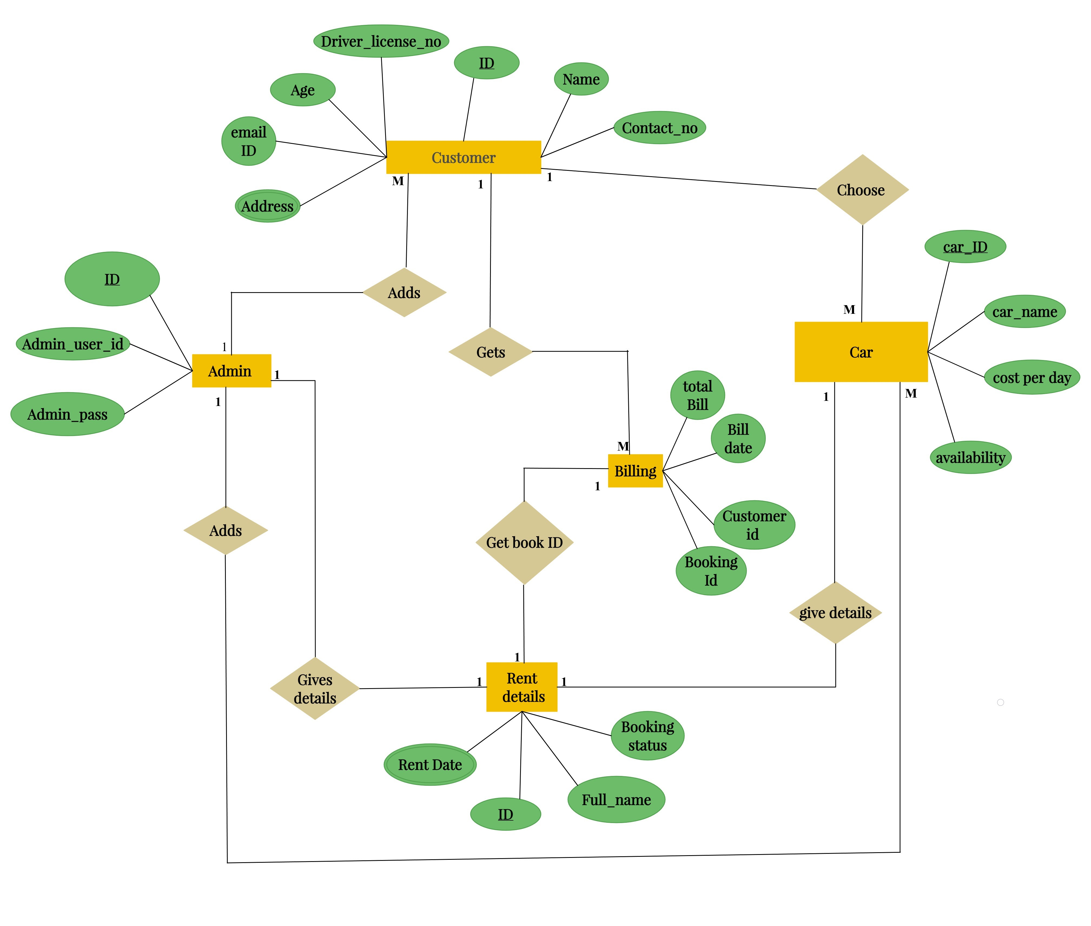

**Context Level Diagram**

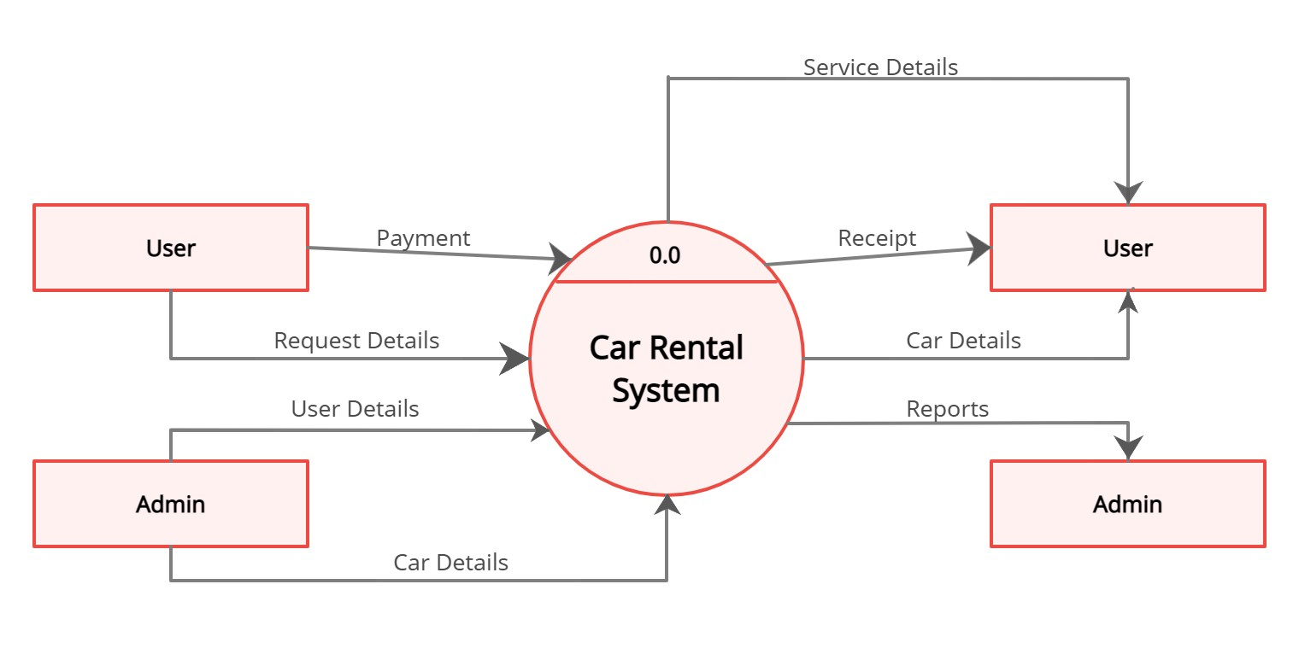

**Data Flow Diagram**

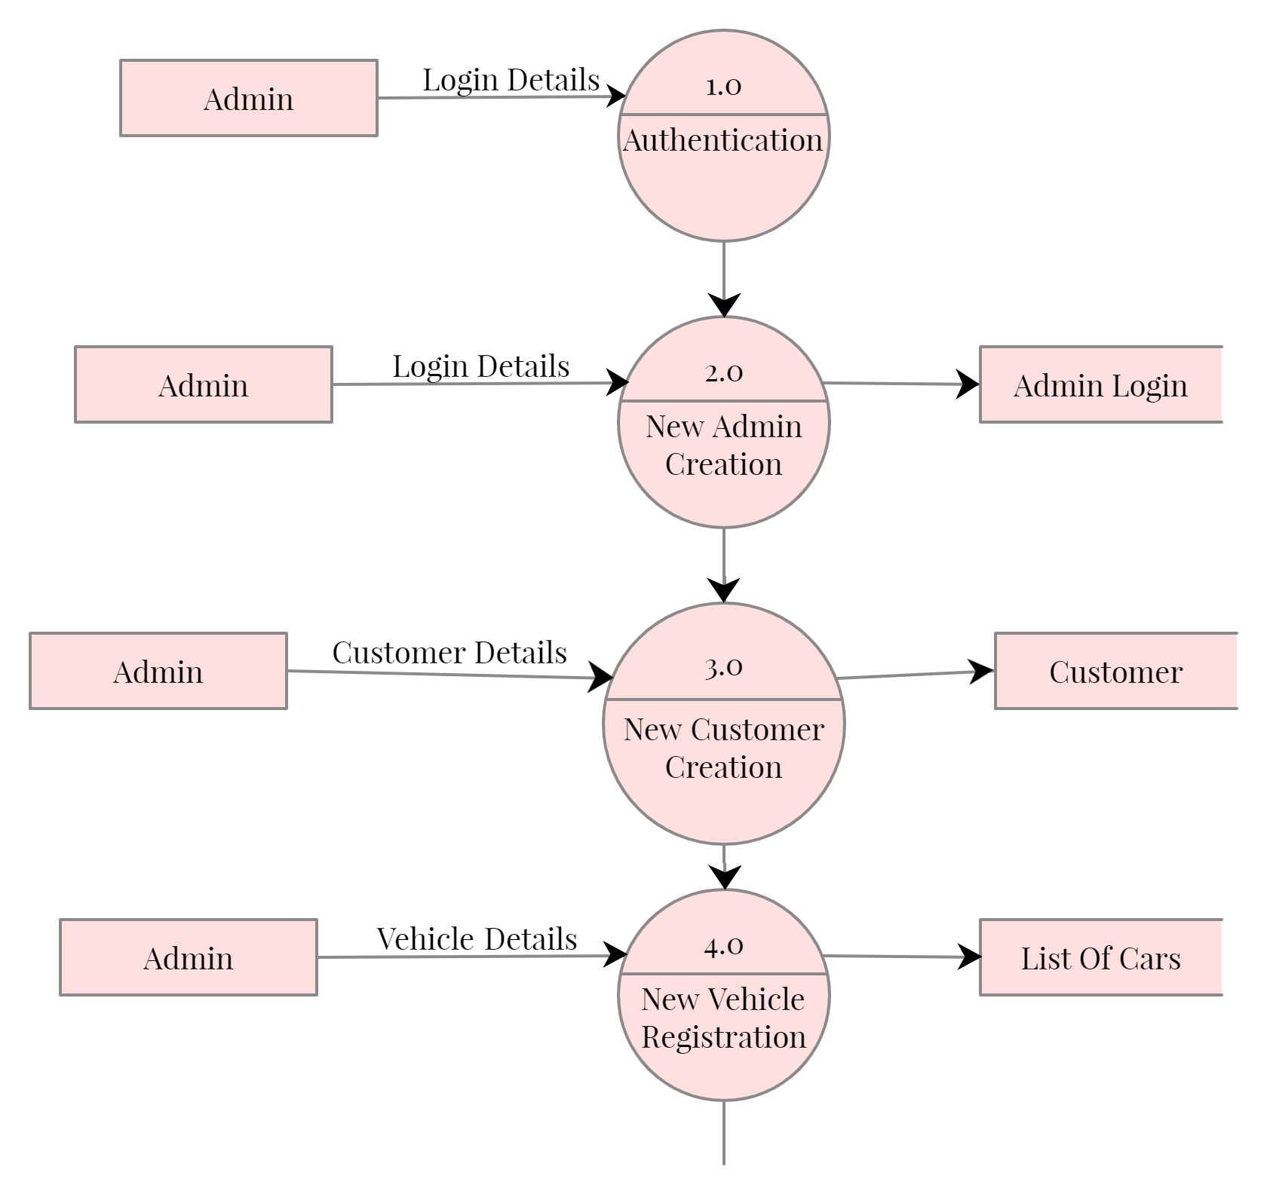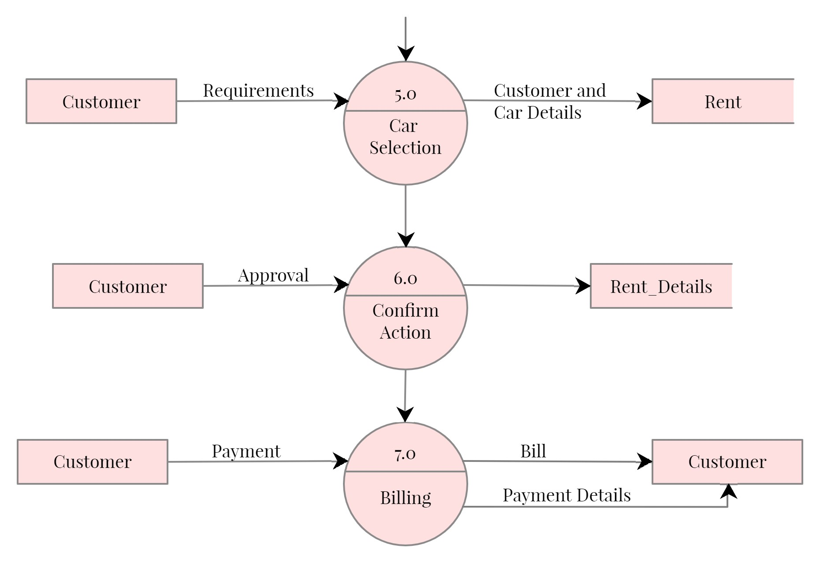

**Data Dictionary**

Admin Login:

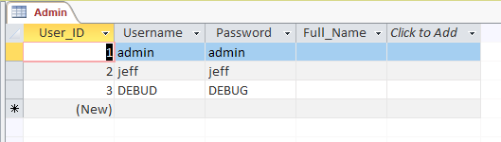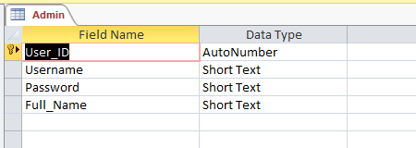

Customer Table:

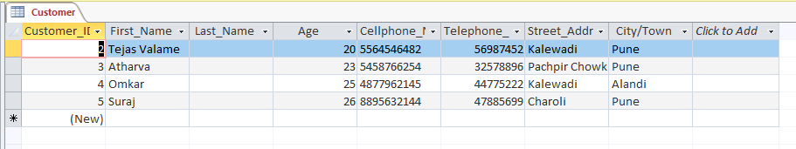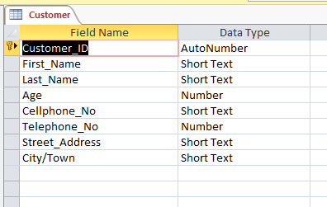

List of Cars:

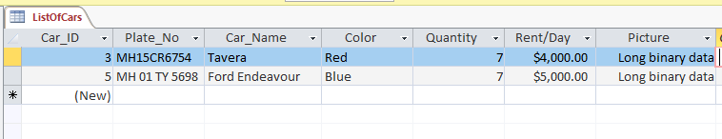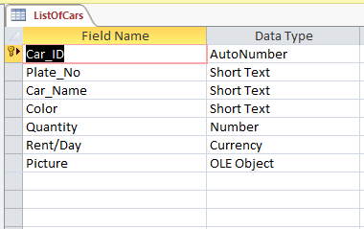

Car rent:

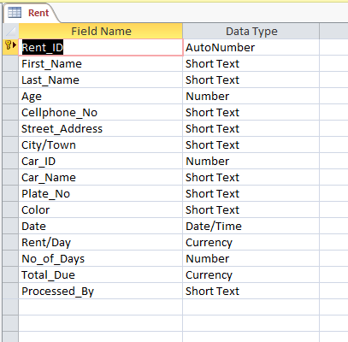

Rent Details table for billing:

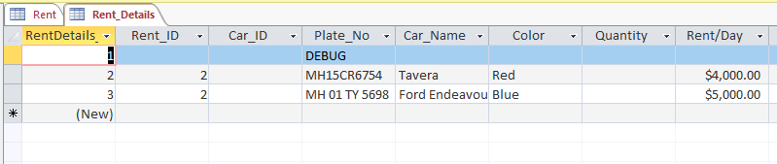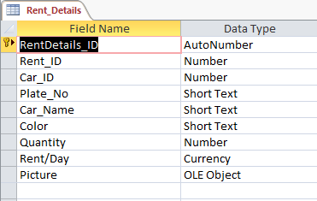

**Form Design with input values**

Admin Login:

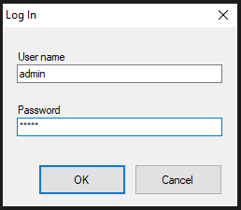

Main Page:

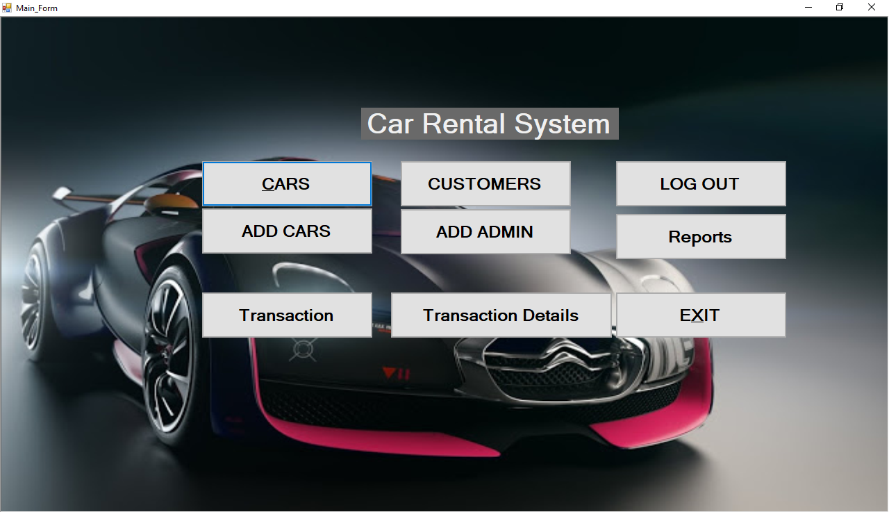

Add Admin:

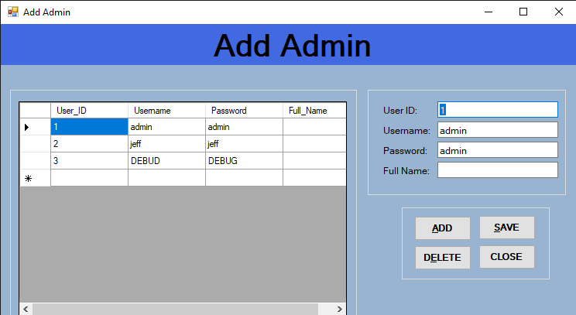

Add Customer:

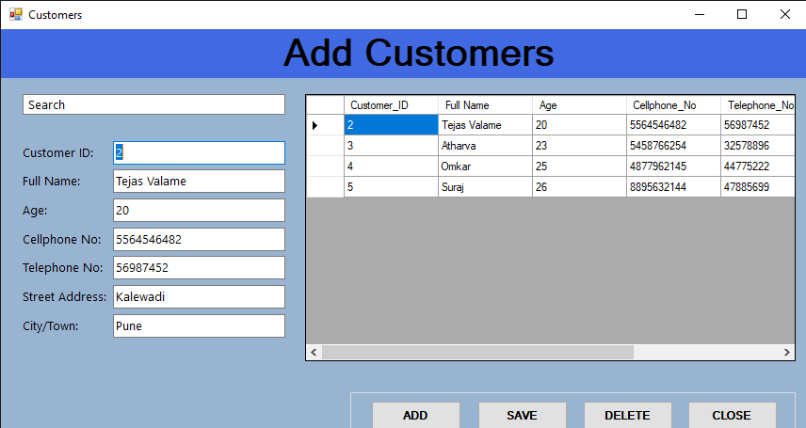

Add Cars:

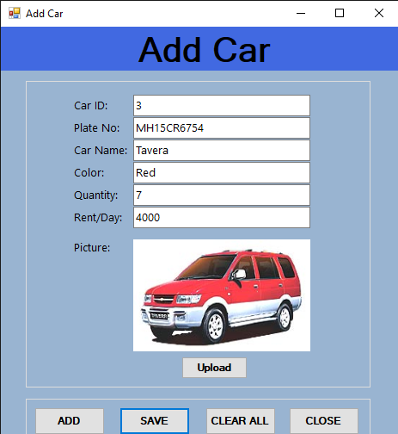

List Of cars:

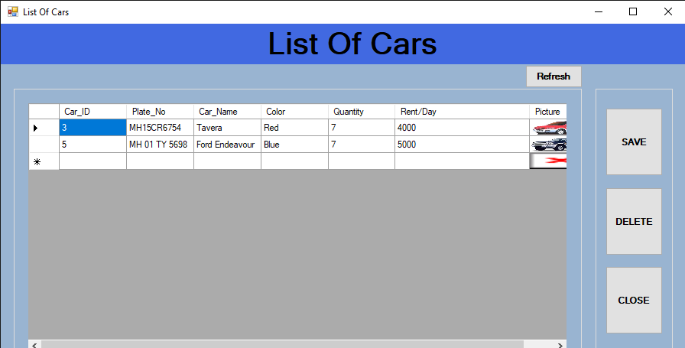

Booking Cars:

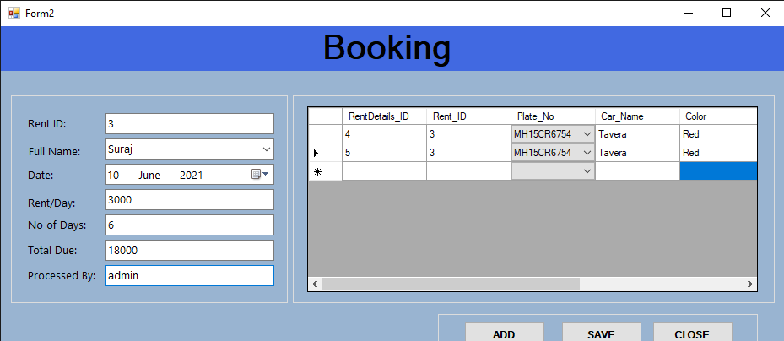

Borrowed Details:

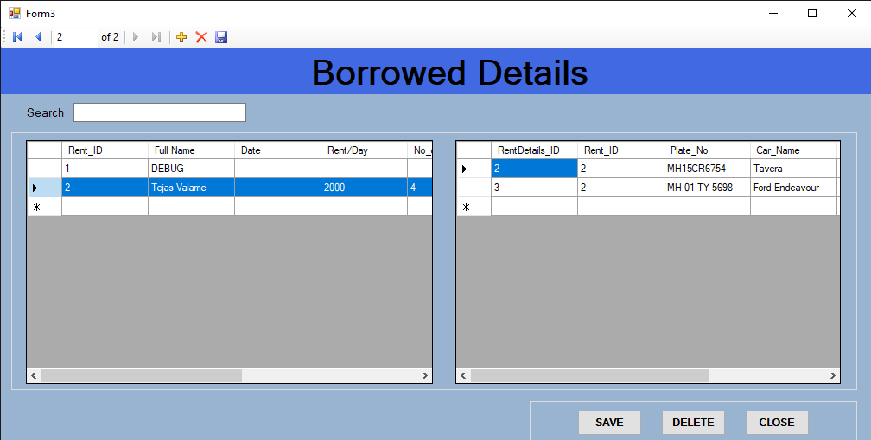

Reports Generation:

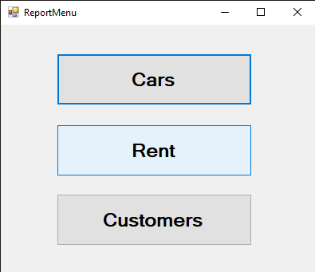

**Reports**

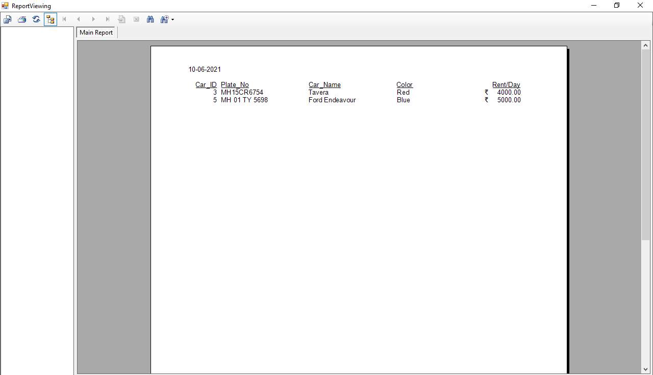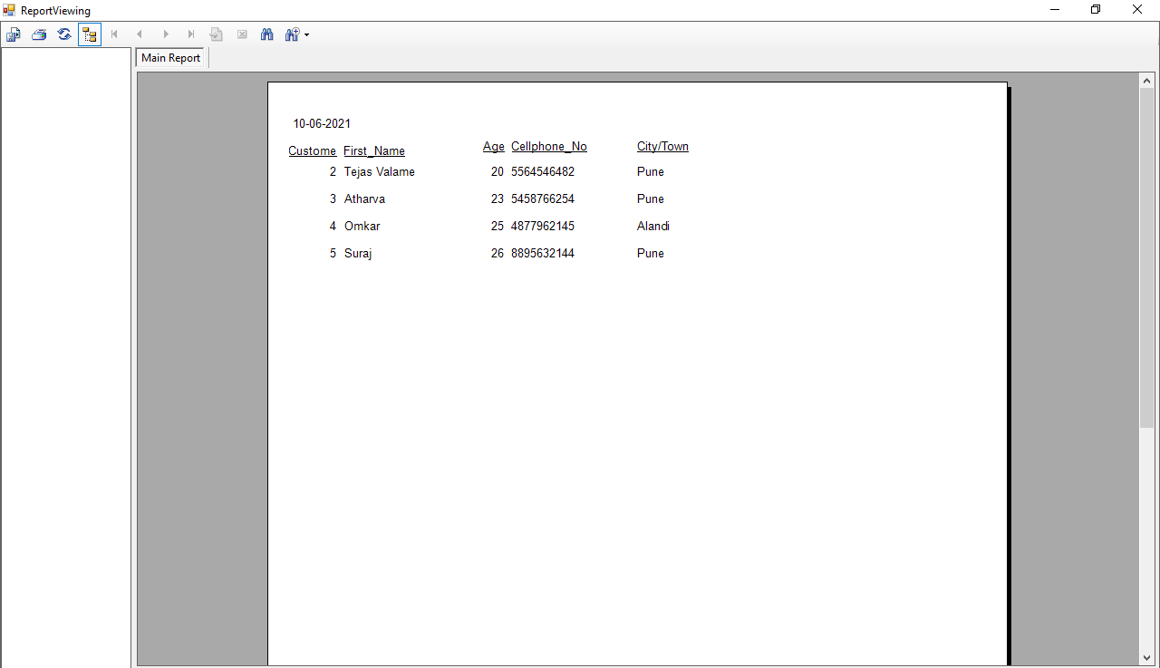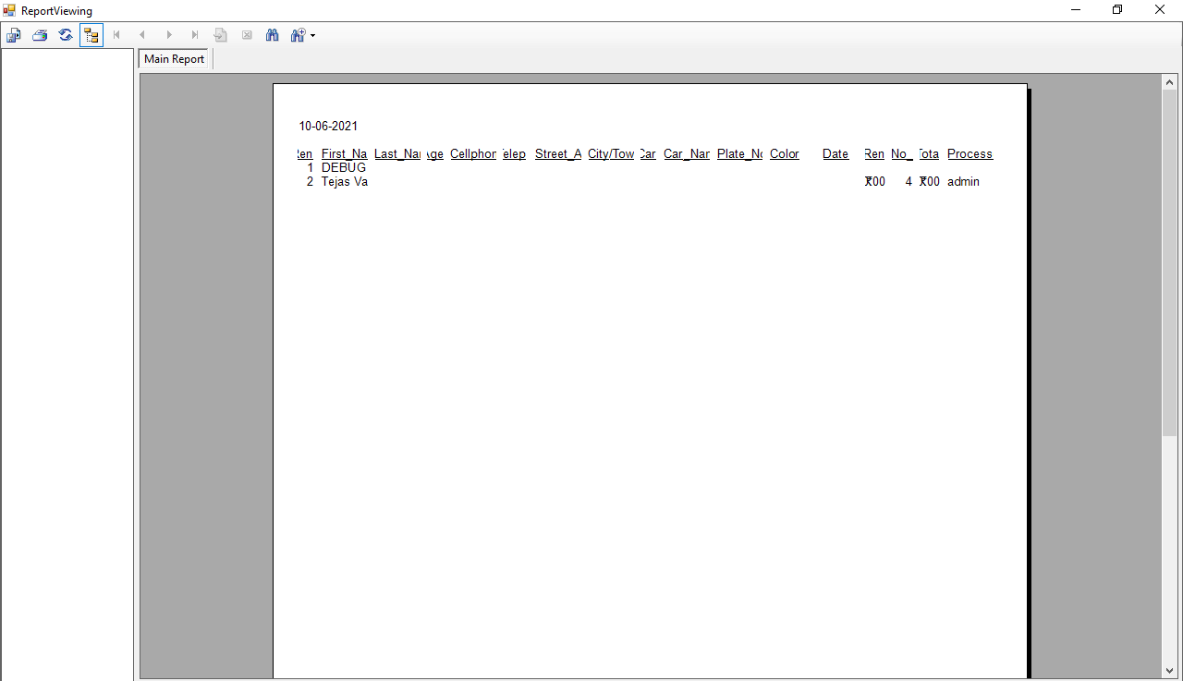

**Advantaged & Limitations**

Advantages:

* The system is convenient to use as the user need to have basic knowledge about computer system.
* Managing vehicle records is simple. Records like date of booking and available cars.
* The system generates the bills as the admin sees fit and all the details are shown in the final bill.
* Reliable.
* The major advantage is that the system is computerized, so, there is less room for error.
* The admin can view a detailed report about all the transactions done in the system.

Limitations:

* The first limitation is that the system is offline.
* Only the Admin can use this system, if the customer has to hire a car then they has to ask the admin.
* As the system is not online the customer has to physically visit the rental shop.

**Future Enhancements**

* In a nutshell, it can be summarized that the future scope of the project circles around security and upgrading to online system.
* Create the master and slave database structure to reduce the overload of the database queries.
* Implement the backup mechanism for taking backup of codebase and database on regular basis on different servers.
* We can also add more complex features, and try to make it more user friendly.
* By upgrading it online we can also add more features like live tracking and secure GPS system.

**Bibliography**

* <https://www.tutorialspoint.com/vb.net/index.html>
* <https://www.tutorialspoint.com/system_analysis_and_design/index.html>
* The Complete Reference Visual Basic .NET

- Jefrey R. Shapiro

* Programming Microsoft Visual Basic.NET

-Francesco Balena